Wagyu AE: Unified Platform Ecosystem Blueprint
The blueprint below illustrates the ecosystem you are building. Wagyu AE is not at the top of a supply chain, but at the center of a network, facilitating and governing the key value flows that connect all participants.
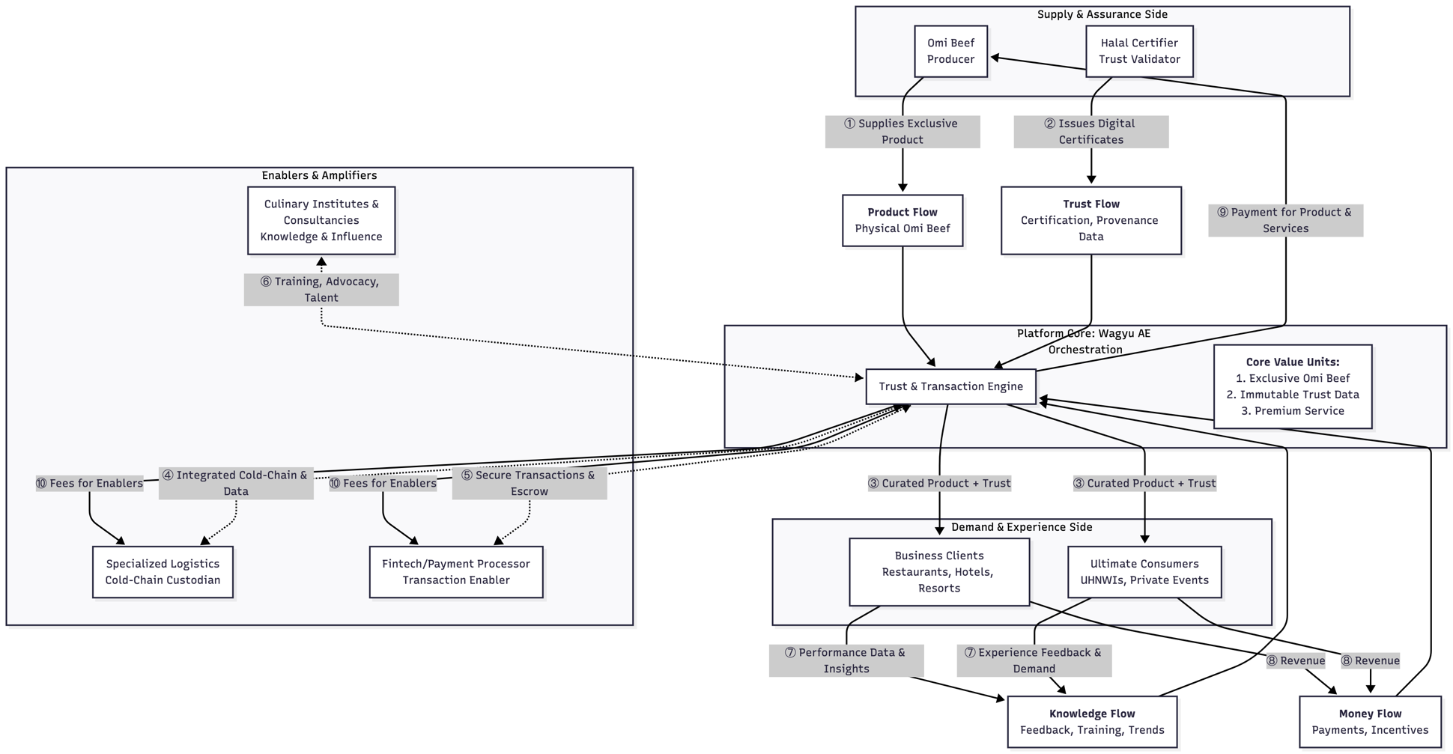

Blueprint Narrative: How the Ecosystem Thrives
This model visualizes the dynamic, multi-directional flows that your platform orchestrates. Here is how each element functions as part of the master plan:

1. The Three Core Value Units (The "What")
Your platform deals in more than meat; it creates and exchanges three critical forms of value:
- Exclusive Omi Beef: The tangible, world-class product.
- Immutable Trust Data: The digital certification, provenance, and handling logs that make the product credible and story-worthy. This is your key differentiator.
- Premium Service: The seamless transactions, reliable logistics, culinary support, and personalized experiences.

2. The Central Orchestrator: The Trust & Transaction Engine (The "How")
This is the beating heart of your platform—the integrated software and business rules that perform five critical functions:
- Matchmaker: Connects the unique supply (rare cuts of Omi Beef) with specific, high-value demand (a resort's wedding, a UHNWI's dinner party).
- Trust Factory: Bundles the physical product with its immutable digital trust passport (from steps ① & ②).
- Governance Layer: Enforces the rules from all your canvases (tiered access, quality standards, penalty clauses) automatically.
- Value Distributor: Facilitates and automates the flow of money and data to the right parties at the right time (steps ⑧, ⑨, ⑩).
- Insights Hub: Aggregates the knowledge flow (step ⑦) to improve the entire ecosystem.

3. Critical Integration Points & Strategic Imperatives
The blueprint reveals that success depends on seamlessly connecting specific flows:
- Integration of Flows ① + ② + ④: This creates your unbreakable "Trust Spine." The product (①), its certificate (②), and its perfect delivery condition (④) must be digitally linked before it reaches the customer. Action: Prioritize building the integrated blockchain/IoT system that makes this possible.
- Activation of Flow ⑥: This is your long-term market dominance strategy. By embedding your standards and product into education and professional consulting, you shape future demand and preferences. Action: Formalize the "Wagyu AE Certified Partner" program for institutes and consultancies.
- Automation of Flow ⑤ + ⑧ + ⑨ + ⑩: This is your efficiency and fairness engine. Smart contracts should ensure that when the caterer pays (⑧), Omi Beef (⑨) and the logistics provider (⑩) are compensated automatically upon verified fulfillment, reducing friction and disputes. Action: Develop the API partnerships with Fintech to enable this conditional logic.

Master Plan: Phased Path to Dominance
Phase 1: Foundation (0-12 Months) – "The Trust Proof"
- Goal: Prove the integrated Trust Spine with a minimum viable ecosystem.
- Actions: Launch with Omi Beef, 1 Halal Certifier, 1 Premium Logistics partner, and onboard 5-10 flagship restaurant and hotel clients. Manually orchestrate high-touch service while building the core Digital Trust Passport system.
Phase 2: Scaling (12-30 Months) – "The Ecosystem Expansion"
- Goal: Scale the proven model and activate network effects.
- Actions: Automate the Trust & Transaction Engine. Open the B2B platform to more restaurants and caterers. Officially launch the B2C Concierge service for UHNWIs. Formalize partnerships with Culinary Institutes to begin influence flow (⑥).
Phase 3: Dominance (30+ Months) – "The Market Standard"
- Goal: Transition from a key distributor to the indispensable platform governor.
- Actions: Leverage aggregated data (⑦) to offer market intelligence subscriptions and co-branded product development with Omi Beef. Make the Wagyu AE certification a must-have credential for chefs and a key spec for consultants. Explore financing services for clients via your Fintech partners.
This Unified Platform Ecosystem Blueprint synthesizes your ten stakeholder canvases into a single, coherent strategy. It shows that your ultimate product is not just Wagyu, but a perfectly orchestrated, trusted network for the premium halal culinary world. Your competitive moat will be the depth of integration and the strength of the trust flows you enable, making Wagyu AE the undisputed central hub for this market.

Wagyu AE Platform Development: Master Gantt Chart
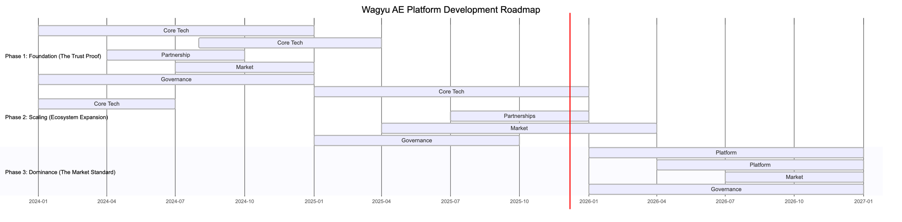

Phase 1: Foundation (Months 0-12) – "The Trust Proof"
- Objective: Prove the integrated value proposition with a manually-curated, high-touch Minimum Viable Ecosystem (MVE).
- Exit Criteria: Successful, flawless execution of 10-15 high-value orders (e.g., for weddings, flagship restaurant menus) with documented client testimonials and verified process integrity.
Workstream | Key Activities & Deliverables | Success Metrics
Core Tech Build | 1. Develop Digital Trust Passport MVP (Blockchain/IoT integration for 1 batch).  2. Build basic B2B Client Portal for ordering & tracking.  3. Set up basic CRM & Inventory System. | Tech stack operational; 100% of test shipments have verifiable digital trace.
Partnership Onboarding | 1. Finalize contracts with Omi Beef, 1 Halal Certifier, 1 Premium Logistics firm.  2. Establish data-sharing protocols and manual integration points (e.g., shared spreadsheets, dedicated contacts). | All contracts signed; operational handshake procedures documented.
Market Launch | 1. Identify and onboard 5-10 Flagship Clients (e.g., 2 luxury hotels, 3 top restaurants, 1 elite caterer).  2. Execute high-touch, manually coordinated pilot orders. | Achieve 15 successful high-value orders; secure 3 case study testimonials.
Governance Design | 1. Document all manual orchestration processes.  2. Draft formal Service Level Agreements (SLAs) and rulebooks for partners and clients. | Process library complete; initial SLAs signed by all launch partners.

Phase 2: Scaling (Months 13-30) – "Ecosystem Expansion"
- Objective: Transition from manual orchestration to automated platform scaling, activating network effects.
- Exit Criteria: Platform processes 80% of transactions automatically; B2C channel is live and profitable; partner programs are active.
Workstream | Key Activities & Deliverables | Success Metrics
Core Tech Build | 1. Develop full Trust & Transaction Engine (automates matching, payments, compliance).  2. Launch B2C Concierge Module (invitation-only web/app).  3. Build Partner Dashboards (for Omi Beef, Logistics). | >80% of order-to-delivery processes are automated; platform uptime >99.5%.
Partnership Growth | 1. Formalize "Certified Partner" programs for Culinary Institutes & Consultancies.  2. Onboard 1-2 additional specialized enablers (e.g., premium packaging, insurance). | 2 major institutes and 3 consultancies in the certified program.
Market Expansion | 1. Scale B2B Client Base to ~50 key accounts across the UAE.  2. Launch and promote B2C Channel to UHNWIs via private wealth networks.  3. Introduce subscription models (e.g., quarterly tasting boxes). | B2B revenue grows 300% from Phase 1; B2C channel achieves 20% monthly growth.
Governance Automation | 1. Implement algorithmic Tiering System.  2. Launch Unified Reputation Dashboard for partners.  3. Activate smart contract escrow with Fintech partner. | Tiering system automatically assigns benefits; >90% of payments are auto-settled.

Phase 3: Dominance (Months 31+) – "The Market Standard"
- Objective: Evolve from a transactional platform to the dominant governance and intelligence hub for the premium halal culinary market.
- Exit Criteria: Wagyu AE is the required certification/marketplace for new market entrants; data products become a significant revenue stream.
Workstream | Key Activities & Deliverables | Success Metrics
Platform Innovation | 1. Launch Data Intelligence Suite (demand forecasting, market trends) sold to partners.  2. Develop Co-Branded Product Lines with Omi Beef for exclusive channel.  3. Explore Embedded Financial Services (e.g., client financing). | Data product revenue contributes >15% of total; launch 1+ co-branded product.
Ecosystem Expansion | 1. Expand to new geographic markets in GCC (Saudi Arabia, Qatar).  2. Explore new verticals (e.g., premium retail, airline catering). | Successful launch in 1 new country; secure 1 major vertical partnership.
Governance Evolution | 1. Establish Ecosystem Advisory Council with key stakeholders.  2. Transition to community-led standard setting (e.g., for new halal luxury products). | Council is active; platform standards are referenced by external industry bodies.

Key Dependencies & Risk Mitigation
- Critical Path: The Digital Trust Passport (Phase 1) is the absolute foundation. Delays here cascade through all other phases. Mitigation: Start with a lightweight, off-the-shelf blockchain service (like VeChain or a hyperscaler tool) to prove the concept before custom build.
- Key Dependency: Fintech Smart Contract integration (Phase 2) requires a partner with advanced API capabilities. Mitigation: Begin technical conversations early in Phase 1 with shortlisted fintechs (e.g., Stripe, local UAE payment innovators).
- Major Risk: Supply Constraint from Omi Beef. Mitigation: The forecast-sharing integration from Phase 1 is critical to align their production with your proven demand, securing your allocation as you scale.
This Gantt chart transforms your strategic vision into a phased execution plan. Each phase builds a tangible asset: first trust, then automated scale, and finally market authority. Would you like to delve deeper into the resourcing or investment plan required for Phase 1: Foundation, to understand the immediate next steps and costs?

